Safe Work Procedure
Location of task/equipment
Department
PPE required (delete any not relevant) |   
Safety precautions (delete any not relevant) | 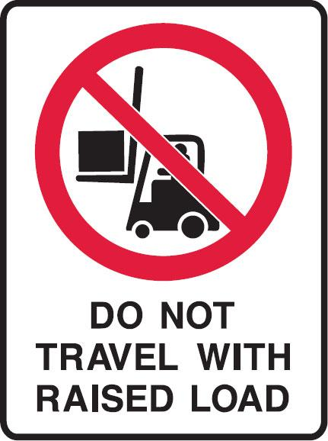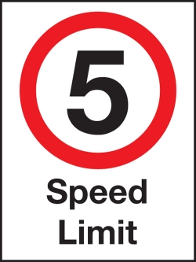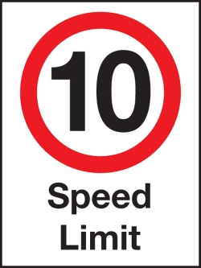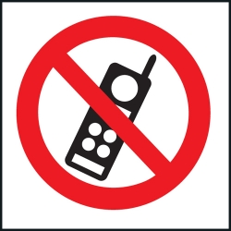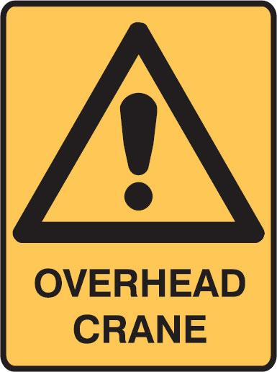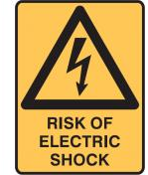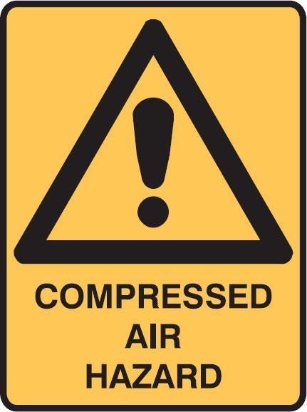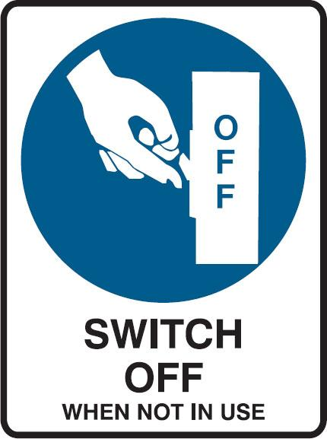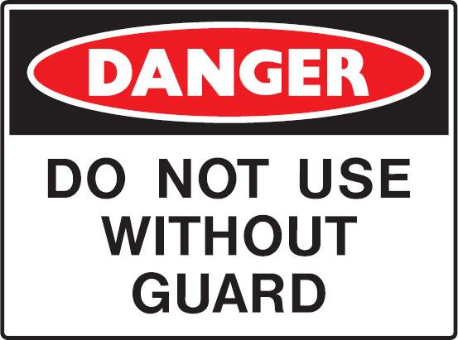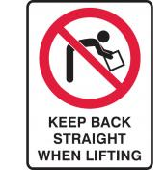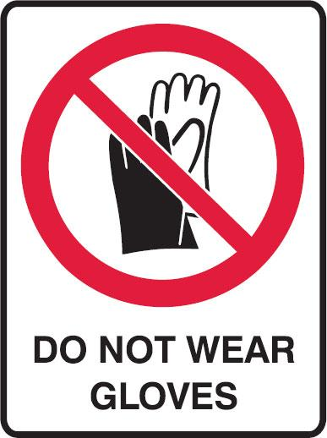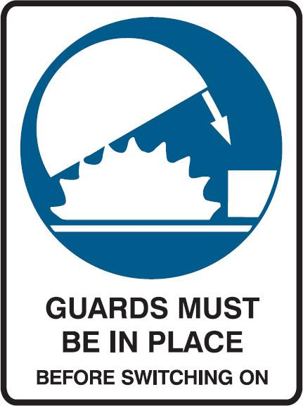
Review date

Operational steps

Prior to commencement (insert steps as required)
- All high-impact energy sources have been identified
- Statutory requirements/Authorisations
- Certification of plant/equipment/structure
- Certification of workers
- Environmental impact considerations
- Spotter(s) needed
- Notification to all associated personnel (incl workers and neighbours)
- Review of specific hazards to be faced
- Access to appropriate hazard control equipment
- Check PPE for suitability to hazard(s), individual needs, fit — and wear as required
- Weather conditions/changes expected

Operating
- Insert steps as required

Emergency/Troubleshooting
- All energy sources have been isolated where possible, and emergency procedures appropriate to the energy considered
- Report all incidents immediately

End of task (insert steps as required)
- Appropriate housekeeping and clean-up of environment

Training requirements for the safe operation of this procedure
- Induction training
- General WHS/OHS legislative awareness
- Manual handling (general)
- Noise
- Hazardous substances
- Electrical hazards
- Use of PPE
- Safe machine operation
- Maintenance & housekeeping procedures
- Injury, illness, damage and near-hit notification
- Accident notification
- Fire and emergency procedures

Related documents
- Insert details

Employee Competency Assessment
This can be used to record whether or not a worker is competent to perform the task outlined in the Safe Work Procedure.

Instructions
Observe the worker to see if they perform the task as described in the procedure and use the appropriate Personal Protective Equipment [PPE].
Ask the participant questions about why they need PPE, why the steps must be taken in the stated order etc — to test their understanding.

TRAINEE
Print name: |  | Assessment
Signature: | Competent |  | Not Competent
Understands what is required to perform this procedure under supervision
Has demonstrated a clear understanding of performing the activity and may perform activities without supervision
Has demonstrated that they are capable of training others in this activity
INSTRUCTOR
Print name: | Date:
Signature:

Completed competency assessment to be returned to Position.

